CAN THO UNIVERSITY
COLLEGE OF INFORMATION AND COMMUNICATION TECHNOLOGY



THESIS BASIS IN
INFORMATION TECHNOLOGY
(HIGH-QUALITY PROGRAM)

Topic

VIETNAM TOURISM WEBSITE

Student: Ho Chi Thanh
Student ID: B2110058
Cohort: K47
Advisor: Dr. Thai Minh Tuan

Can Tho, 04/2024

CAN THO UNIVERSITY
COLLEGE OF INFORMATION AND COMMUNICATION TECHNOLOGY
DEPARTMENT OF INFORMATION TECHNOLOGY



THESIS BASIS IN
INFORMATION TECHNOLOGY
(HIGH-QUALITY PROGRAM)

Topic

VIETNAM TOURISM WEBSITE

Student: Ho Chi Thanh
Student ID: B2110058
Cohort: K47
Advisor: Dr. Thai Minh Tuan

Can Tho, 04/2024

ACKNOWLEDMENTS
I would like to express my sincere gratitude to Dr. Thai Minh Tuan for his invaluable guidance and support throughout the process of selecting a suitable research topic and completing my undergraduate thesis. I am deeply appreciative of the time and dedication he has devoted to helping me achieve success in my research endeavor.
Due to time constraints, limited knowledge, and lack of experience, this thesis report inevitably contains shortcomings and limitations. I sincerely hope to receive his valuable feedback, suggestions, and corrections to improve the presentation and content of the report. These contributions will serve as precious assets for my future academic pursuits.
Thank you sincerely.

MỤC LỤC
ACKNOWLEDMENTS 3
ABSTRACT 6
CHAPTER 1: INTRODUCTION 7
1. Background 7
2. Objective 7
3. Object and Scope of research 8
3.1. Research Objects 8
3.2. Research Scope 8
4. Research Methodlogy 8
4.1. Theoretical Aspect 8
4.2. Practical Aspect 9
5. Thesis Structure 9
CHAPTER 2: CONTENT 10
1. Requirements specification 10
2. Solution design and technologies 10
2.1. Technologies 10
2.1.1. VueJs 10
2.1.2. Spring Boot 11
2.1.3. MySQL 12
2.1.4. Visual Studio Code 12
2.2. Solution design 13
2.2.1. Usecase Diagram 13
2.2.1.1. Client 13
2.2.1.2. Manager 13
2.2.2. Design Database 14
2.2.2.1. Entity Relational Diagram 14
2.2.2.2. Tour Table 15
2.2.2.3. Destination Table 16
2.2.2.4. Tour type Table 16
2.2.2.5. User Table 16
2.2.2.6. Admin Table 16
2.2.2.7. Booking Table 16
2.3. Solution Implementation 17
2.3.1. Main Functions 17
2.3.1.1. Log in 17
2.3.1.2. Register 17
2.3.1.3. Filter Tour 18
2.3.1.4. Booking Tour 18
2.3.2. User Interface 19
2.3.2.1. Home page interface 19
2.3.2.2. Login interface 19
2.3.2.3. Register interface 21
2.3.2.4. Tour detail interface 23
2.3.2.5. Booking interface 24
2.3.2.6. Filter interface 25
2.3.2.7. Tour Management interface 25
2.3.2.8. Booking Management 26
CHAPTER 3: CONCLUSION 27
1. Result achieved 27
2. Limitation 27
3. Future Directions 27

ABSTRACT
Recognizing the nation's diverse and rich tourism potential, the Vietnamese government has identified tourism as a spearhead economic sector. However, the COVID-19 pandemic dealt a severe blow to Vietnam's tourism industry, causing significant disruptions and setbacks. With the pandemic subsiding, the tourism sector has witnessed a remarkable resurgence, driven by the growing demand from both domestic and international travelers seeking to explore the wonders of Vietnam.
In response to this burgeoning demand, the "Vietnam Tourism Website" has emerged as a comprehensive online platform, meticulously crafted to cater to the needs of discerning travelers eager to immerse themselves in the captivating beauty of the "S" shaped country. This meticulously designed website empowers globetrotters with a wealth of features, enabling them to seamlessly navigate, explore, and customize their travel itineraries to perfectly align with their preferences.

CHAPTER 1: INTRODUCTION
- Background
The tourism industry in Vietnam is experiencing a strong recovery after the COVID-19 pandemic. Vietnam has welcomed over 12.6 million international visitors and 108 million domestic tourists. However, the tourism sector still faces numerous challenges, including fierce competition from other countries in the region and globally.
To enhance competitiveness and achieve sustainable development, the tourism industry in Vietnam needs to capitalize on opportunities presented by the digital transformation era. By integrating information technology into management, business operations, and tourism promotion effectively, Vietnam can further develop its tourism potential.
Recognizing this issue and building upon existing applications, the "VietNam tourism website" project has been initiated. This website aims to facilitate the search for tours in Vietnam, catering to the preferences and interests of tourists. It also serves as a platform to promote Vietnam's beauty, culture, and hospitality internationally, attracting a large number of domestic and international tourists to Vietnam. This initiative contributes to the local tourism development and socioeconomic progress of the country.
The target users of this project are both domestic and international tourists, as well as tourism businesses. The goal is to provide accurate and up-to-date information about tourist destinations, services, and Vietnamese culture, enabling tourists to easily book services and improving the quality of tourism services in Vietnam.
- Objective
Overall objective: To develop a user-friendly and convenient online tour booking platform that effectively promotes Vietnam's stunning landscapes and rich cultural heritage.
Specific objective: Establish two user subsystems for the website:
- Customer User Subsystem:
+ User registration
+ User login
+ Tour searching
+ Tour booking
+ Tour booking history
+ Tour cancellation
- Management User Subsystem:
+ Admin login
+ Tour addition, editing and deletion
+ Tour booking confirmation
+ Tour cancellation confirmation
- Object and Scope of research
  - Research Objects
This project focuses on designing a modern, user-friendly, and engaging website interface that effectively attracts customers. Additionally, the project explores performance optimization to ensure a smooth website experience.
  - Research Scope
Based on a thorough understanding of theoretical frameworks and related research, the research scope is outlined as follows:
- Website Design: The website will be designed for small to medium-sized businesses.
- Technology Implementation: The website will utilize modern and userfriendly technologies.
- Hosting Optimization: The website will be deployed on hosting services that offer the lowest hosting costs.
- Research Methodlogy
  - Theoretical Aspect
This research project synthesizes knowledge acquired in the areas of information system design analysis, database management, and web programming. Alongside, modern technologies and design methodologies such as Spring Boot, Vue.js, and RESTful API are integrated to form a cohesive system. Therefore, from a theoretical perspective, the following aspects will be covered:

- Study of information system design principles for data modeling and processing component design.
- Understanding the architecture of Spring Boot for server-side logic implementation.
- Exploration of the lifecycle of components in Vue.js and their interactions during web application development.
  - Practical Aspect
- Development of a user-friendly and convenient tour booking website.
- Implementation of features such as tour search, booking for customers, and tour addition, modification, and deletion for administrators.
- Designing a simple and modern user interface, optimizing the user experience.
- Thesis Structure
Chapter 1: Introduction
General introduction to the topic
Chapter 2: Content
- Requirements specification
- Solution design and technologies
- Solution implementation
Chapter 3: Conclusion
- Achieved results
- Future directions

CHAPTER 2: CONTENT
- Requirements specification
A website operates with two main components: an administrator and customers. The administrator is provided with an admin account to log into the admin page, where they manage all activities related to the website such as monitoring customer visits, the number of tours booked, etc. Customers have the ability to book tours, search for tours, and view information about booked tours.
Each tour on the website is managed through a tour code, tour name, description, number of guests, departure date, return date, tour type, and tour price. Each tour type is managed by a type code and type name. Each tour belongs to only one tour type.
Each customer is managed by a customer code, name, gender, and address. Customers can book multiple tours. When customers perform functions such as booking a tour or viewing information about booked tours, they must log in with a pre-registered account.
The basic functionalities that the website needs to support for both customers and administrators are as follows:
For customers:
- Account-related functions: registration, login
- Tour search by date, destination, booking tours, viewing information about booked tours
For administrator:
- Login
- Add, edit, delete tour information
- Confirm customer tours
- Solution design and technologies
  - Technologies
    - VueJs
Vue.js, an open-source JavaScript framework, has gained popularity since its creation by Evan You in 2014. Alongside other well-established frameworks like React and Angular, Vue.js has become a go-to choice for web developers.
Designed for seamless integration into existing projects, Vue.js offers a flexible approach to building Single Page Applications (SPAs) and interactive user interfaces. Its adaptable syntax and strong community support make it appealing to both novice developers and seasoned professionals.
One standout feature of Vue.js is its focus on the user interface (UI) layer and component reusability. Developers can create reusable UI components and combine them to build complex applications with distinct layers. Additionally, Vue.js comes with a robust ecosystem of libraries and tools, such as VueFire (integrating with Firebase) and VueAxios (integrating with Axios).
Easy to learn and use, Vue.js is an ideal choice for modern web development, whether you’re working on small projects or large, intricate applications.
    - Spring Boot
Spring Boot, developed by the Pivotal Team (now VMWare), is a framework designed to streamline the process of building web applications quickly and easily. It reduces the complexity of configuration and deployment by offering intelligent default settings and integrating popular libraries from the Spring ecosystem.
One of Spring Boot’s strengths lies in its automatic configuration capabilities. Instead of manual adjustments, Spring Boot utilizes “starters” to automatically install and integrate relevant libraries such as Hibernate and Spring Data JPA. This eliminates the need for step-by-step manual configuration often required in traditional Spring projects. As a result, developers can focus on building the logic components of their system without worrying about library compatibility.
Spring Boot’s architecture is divided into four distinct layers: presentation, business logic, data interaction, and database. Each layer plays a specific role within the web system. The presentation layer is closest to end-user applications, while the database layer represents the lowest level, handling system entities. By breaking down processing components into separate modules across these layers, Spring Boot facilitates efficient source code management, enhances maintainability, and supports easy scalability.
Lastly, Spring Boot benefits from a large and longstanding user community. Documentation, tutorials, and solutions for specific development challenges are readily available on forums, knowledge-sharing websites, and online user communities. Thanks to contributions from thousands of developers worldwide, the framework continues to evolve, receive maintenance, and add new features while ensuring backward compatibility for legacy systems.
    - MySQL
MySQL is a robust and widely used open-source database management system for storing and managing data in web applications. With MySQL, you can create databases, tables, and execute queries to retrieve, update, or delete data. It supports various data types, ranging from basic types like integers and strings to more complex data such as images and audio.
Additionally, MySQL offers strong security features to safeguard your data. User management and access permissions allow careful control over who can access and manipulate data within the system. MySQL also provides a range of database management tools, including command-line interfaces and graphical applications like phpMyAdmin, making database administration easy and efficient.
Thanks to its powerful and flexible features, MySQL is an ideal choice for data storage and management in web applications and other software projects, enabling the development of high-performance and secure applications.
    - Visual Studio Code
Visual Studio Code (VSCode) is a lightweight but powerful open-source source code editor developed by Microsoft. Launched in 2015, VSCode quickly became one of the most popular tools for programmers. Its standout feature is flexibility and extensibility, allowing users to customize and enhance functionality through extensions and flexible configuration.
Another strong point of VSCode is its sleek and intuitive user interface, combined with features like automatic code completion and intelligent suggestions that boost programming productivity. VSCode supports various programming languages and popular technologies, from JavaScript and HTML/CSS to React and Vue.js, providing a consistent experience across different projects.
Furthermore, VSCode integrates seamlessly with source code analysis tools and version control systems like Git, enabling efficient collaboration and effective tracking of code history. Its flexibility, performance, and robust community support make VSCode a top choice for developers worldwide.
  - Solution design
    - Usecase Diagram
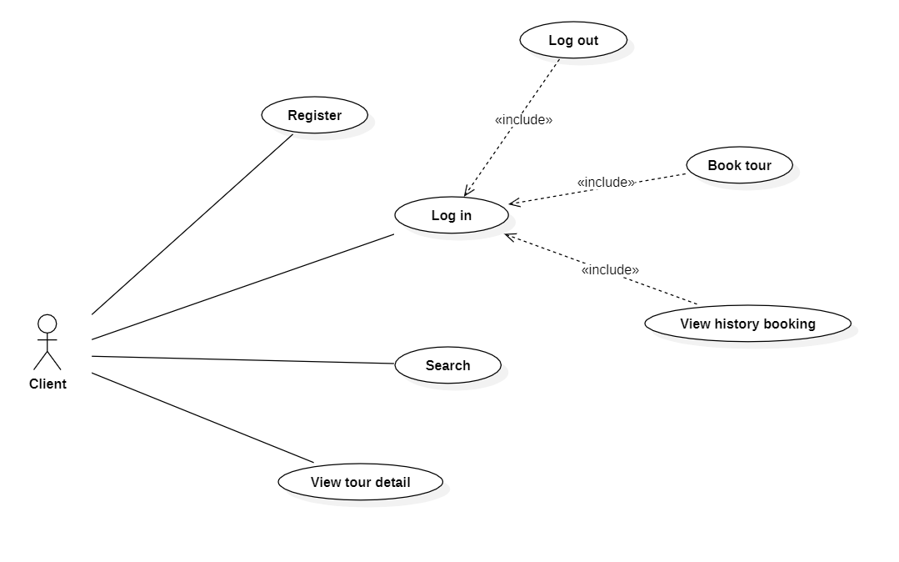
      - Client
This use case diagram was constructed to illustrate the functionalities that customers can perform. These functionalities include account registration, login, tour information search, viewing tour details, booking tours, viewing booking history, and logging out. Clear constraints were defined between functions to ensure consistency and user safety.
      - Manager

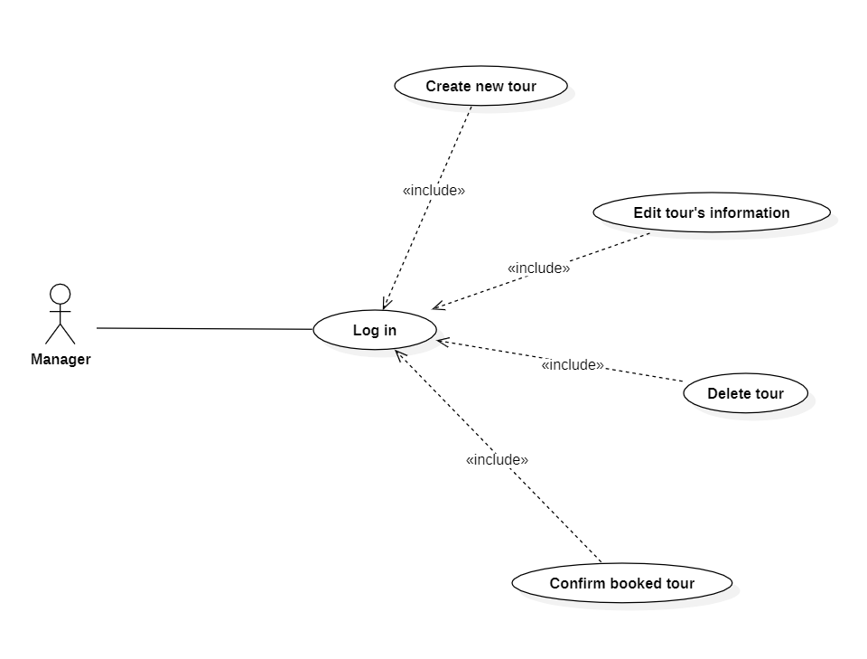
This use case diagram was constructed to illustrate the functionalities that customers can perform. These functionalities include login, create new tour, edit tours’s information, delete tour, and confirm customer’s booked tours. Clear constraints were defined between functions to ensure consistency and user safety.
    - Design Database
      - Entity Relational Diagram

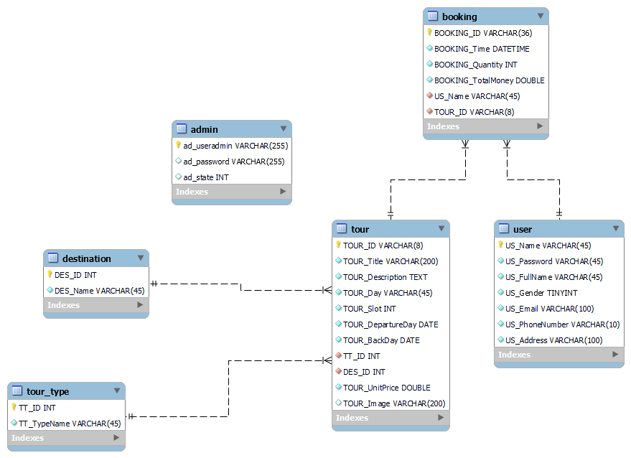
      - Tour Table
Name Column | Data Type | Constraint | Note
TOUR_ID | VARCHAR(8) | Primary key, not null
TOUR_Title | VARCHAR(200) | Not null
TOUR_Description | TEXT | Not null
TOUR_Day | VARCHAR(45) | Not null
TOUR_Slot | INT | Not null
TOUR_DepartureDay | DATE | Not null
TOUR_BackDay | DATE | Not null
TOUR_UnitPrice | DOUBLE | Not null
TOUR_Image | VARCHAR(200)
TT_ID | INT | Foreign key, not null | Tour type
DES_ID | INT | Foreign key, not null | Destination

      - Destination Table
Name Column | Data Type | Constraint | Note
DES_ID | INT | Primary key, not null
DES_Name | VARCHAR(45) | Not null

      - Tour type Table
Name Column | Data Type | Constraint | Note
TT_ID | INT | Primary key, not null
TT_TypeName | VARCHAR(45) | Not null

      - User Table
Name Column | Data Type | Constraint | Note
US_Name | VARCHAR(45) | Primary key, not null
US_Password | VARCHAR(45) | Not null
US_FullName | VARCHAR(45) | Not null
US_Gender | TINYINT | Not null
US_Email | VARCHAR(100) | Not null
US_PhoneNumber | VARCHAR(10) | Not null
US_Address | VARCHAR(100) | Not null

      - Admin Table
Name Column | Data Type | Constraint | Note
AD_UserAdmin | VARCHAR(255) | Primary key, not null
AD_Password | VARCHAR(255) | Not null
AD_State | INT

      - Booking Table

Name Column | Data Type | Constraint | Note
BOOKING_ID | VARCHAR(36) | Primary key, not null
BOOKING_Time | DATETIME | Not null
BOOKING_Quantity | INT | Not null
BOOKING_TotalMonet | DOUBLE | Not null
US_Name | VARCHAR(45) | Foreign key, not null | User name
TOUR_ID | VARCHAR(8) | Foreign key, not null

  - Solution Implementation
    - Main Functions
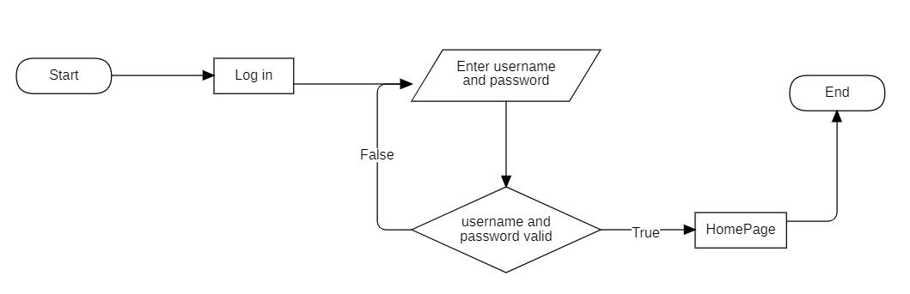
      - Log in
When users select the “Log in” option, they will need to enter their username and password and click the “Log in” button. The system will verify whether the entered username and password match the data stored in the database. If the authentication is successful, the website will redirect the user to the homepage. If authentication fails, the user will be prompted to re-enter their login information.
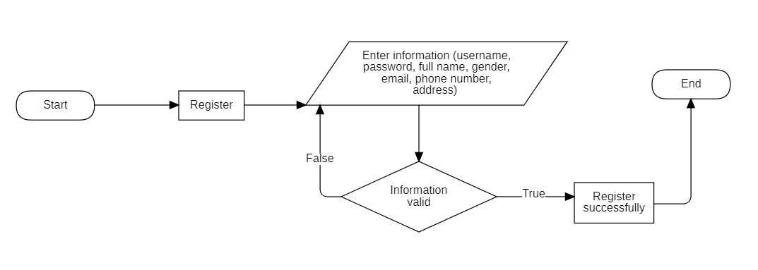
      - Register
When users register, they need to fill in all the required information in the registration form and then click the “Register” button. The system will validate whether the entered information is valid. If it is valid, a success message will be displayed to the user indicating successful registration. If not, the user will be prompted to re-enter the information.
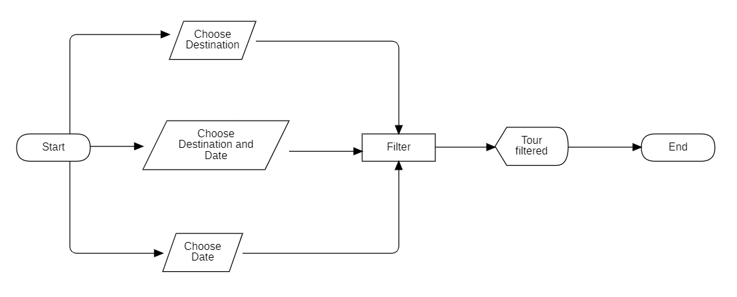
      - Filter Tour
Users can search for tours based on their destination, time, or both. After selecting the search criteria, they can click the ‘Search’ button, and the website will display tours that match the specified conditions.
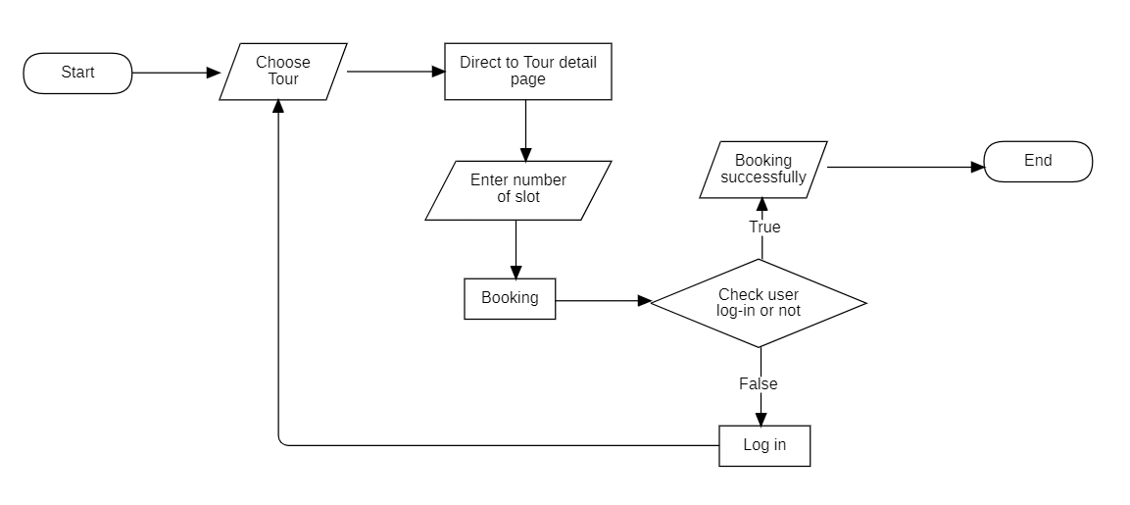
      - Booking Tour
To book a tour, users start by selecting the desired tour from the homepage. They are then directed to the detailed page for the chosen tour. On this page, users find comprehensive information about the tour, including an available form where they can input the number of seats they wish to reserve. When users click the “Book Tour” button, the website checks whether they are already logged in. If not, a login form is displayed. If the user is already logged in, a successful booking confirmation is provided.
    - User Interface
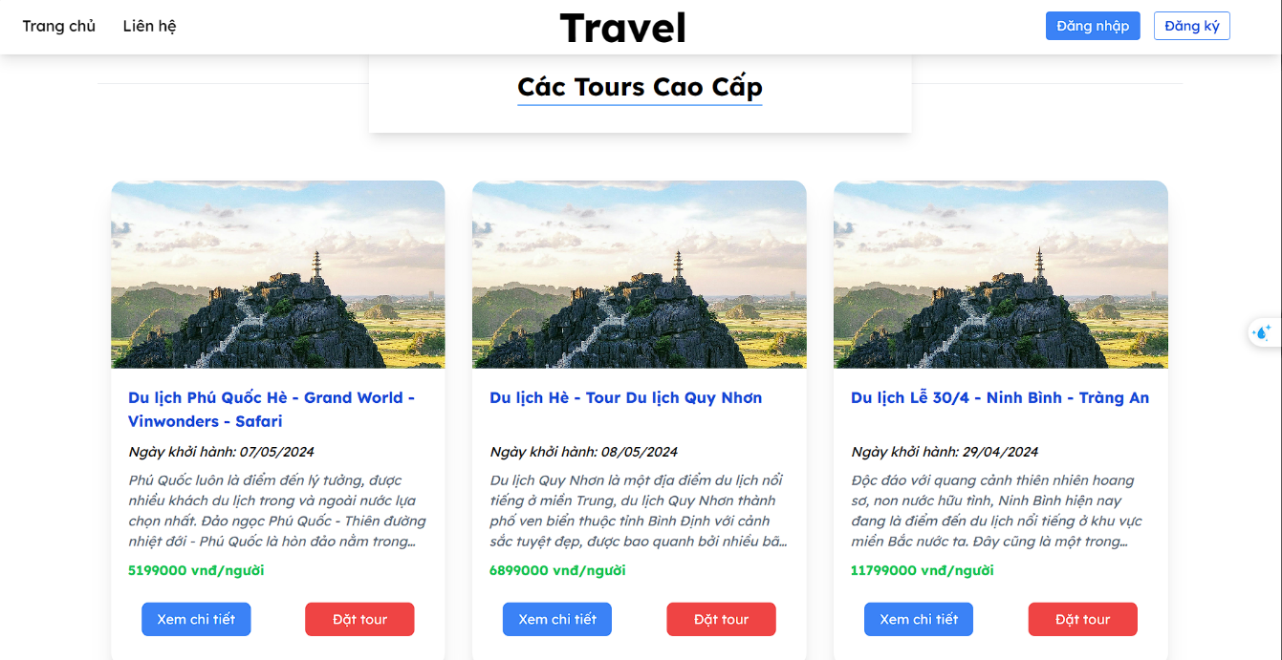
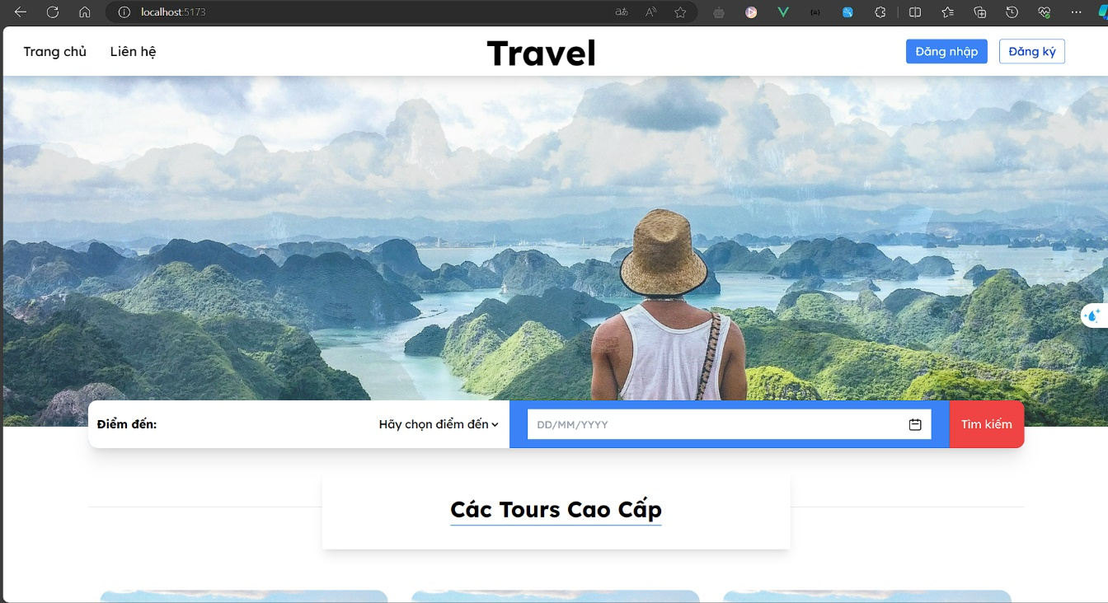
      - Home page interface

      - Login interface

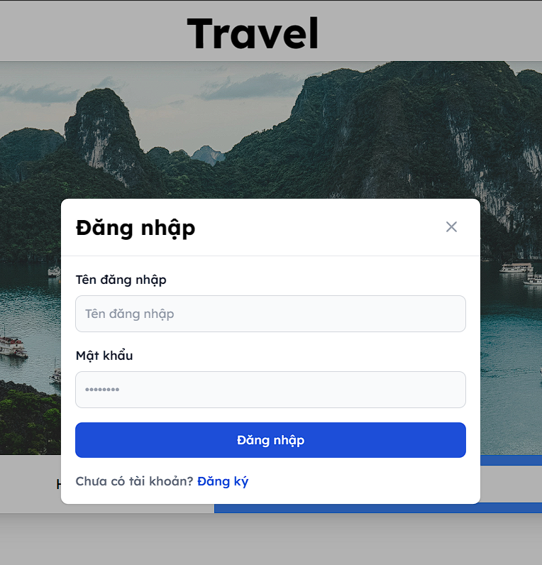

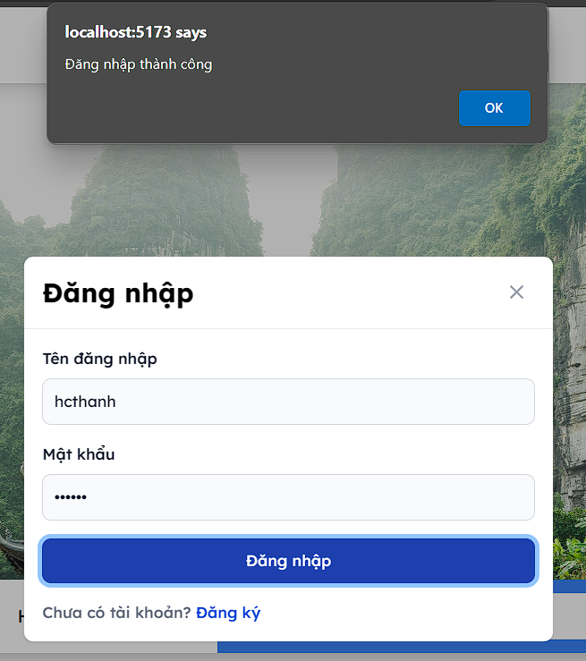

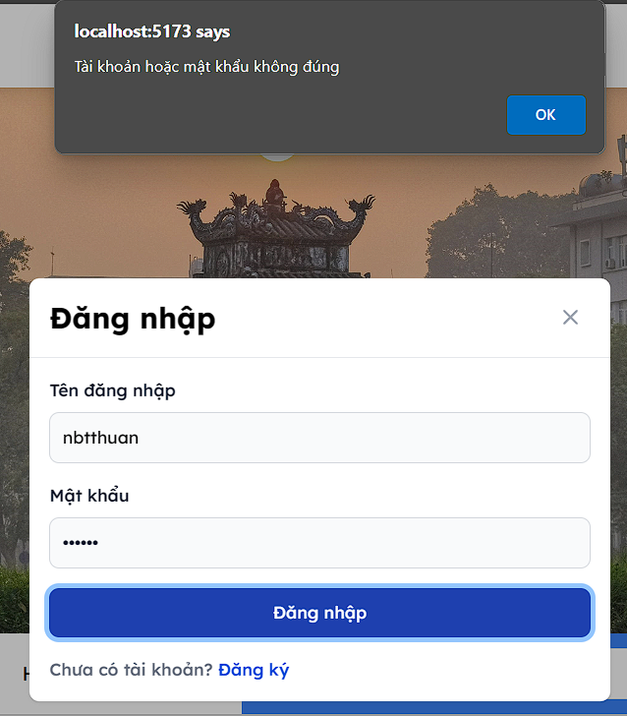

      - Register interface

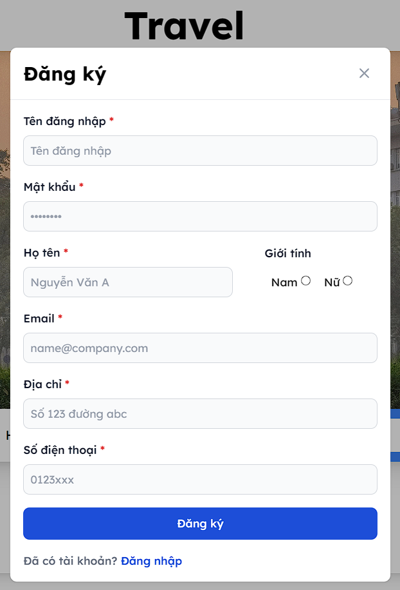

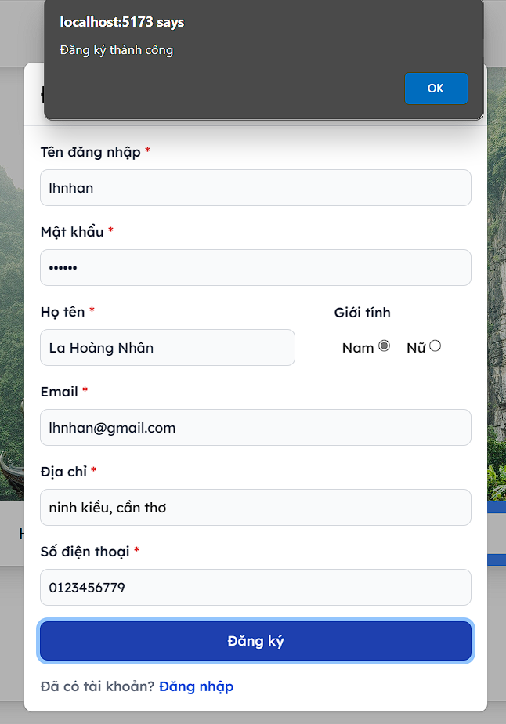

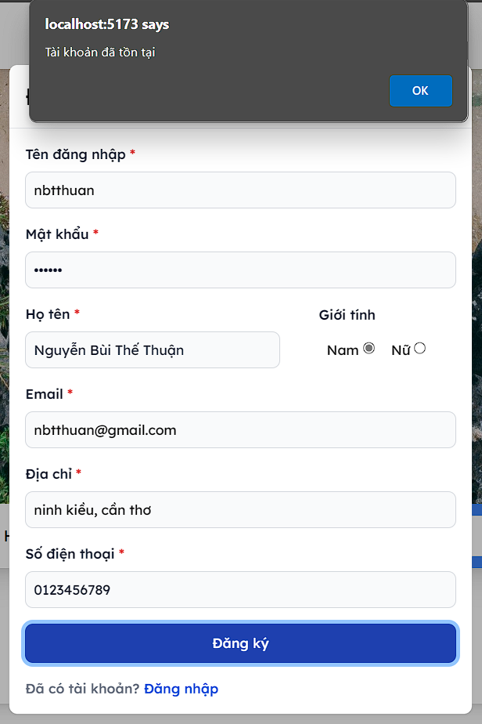

      - Tour detail interface

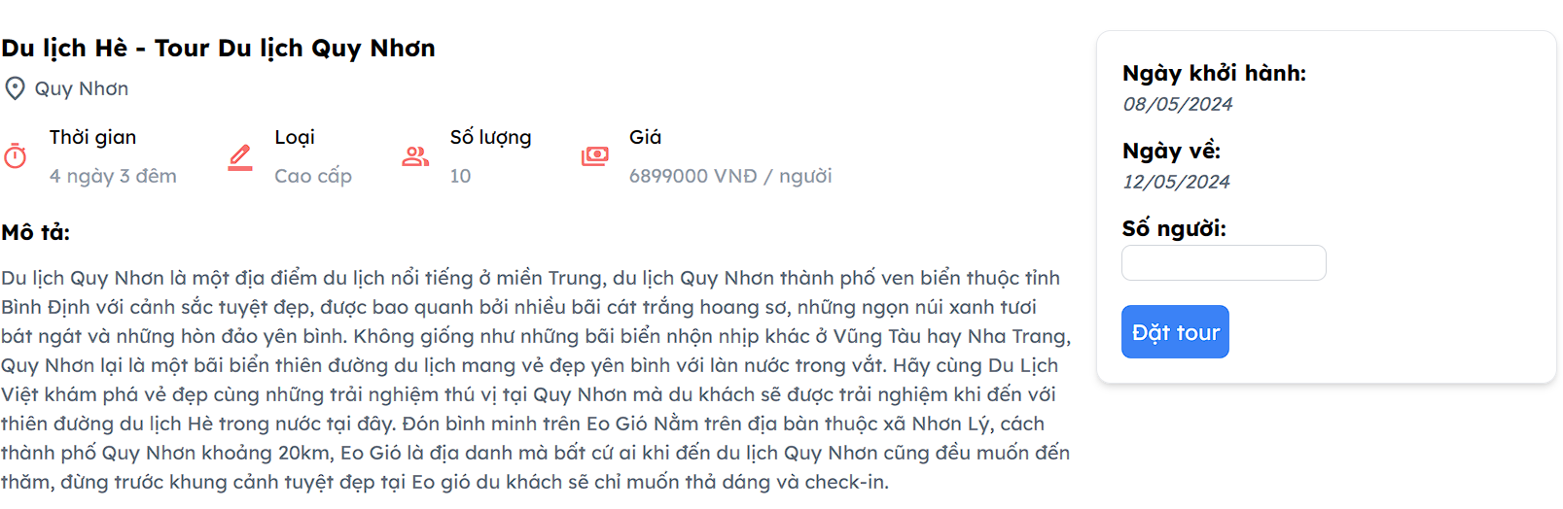
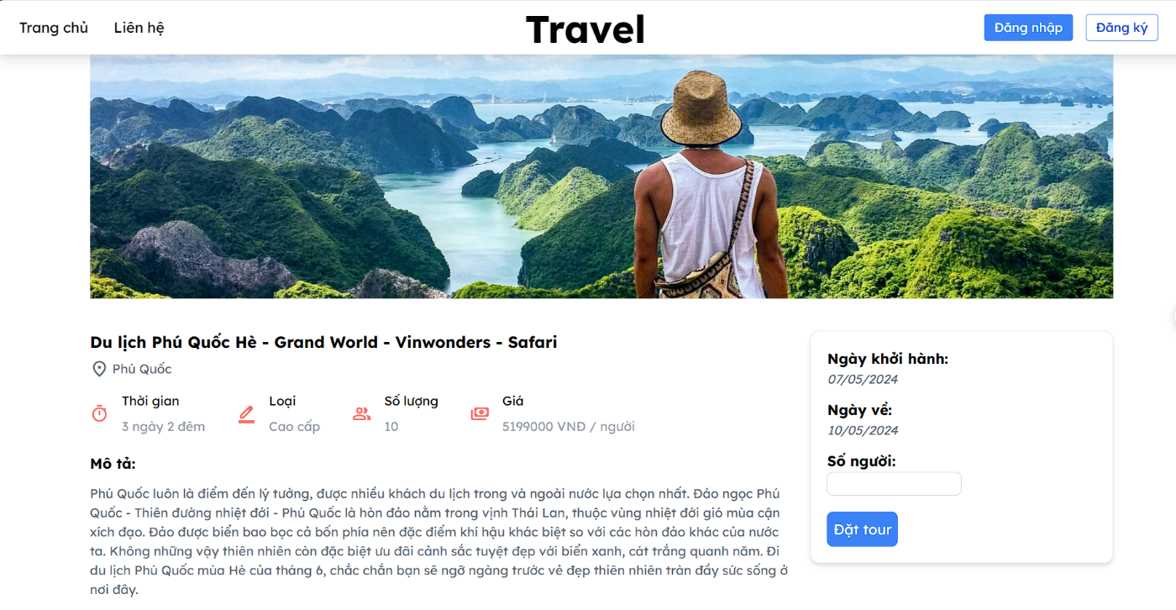
      - Booking interface
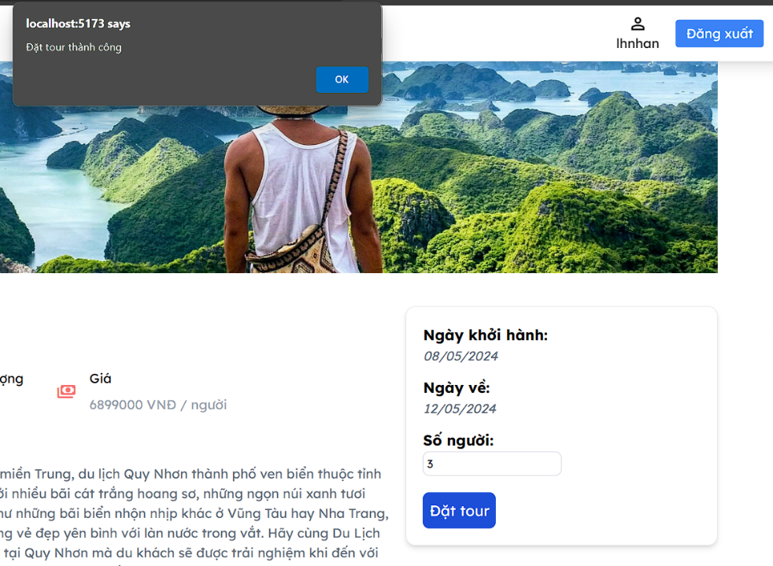

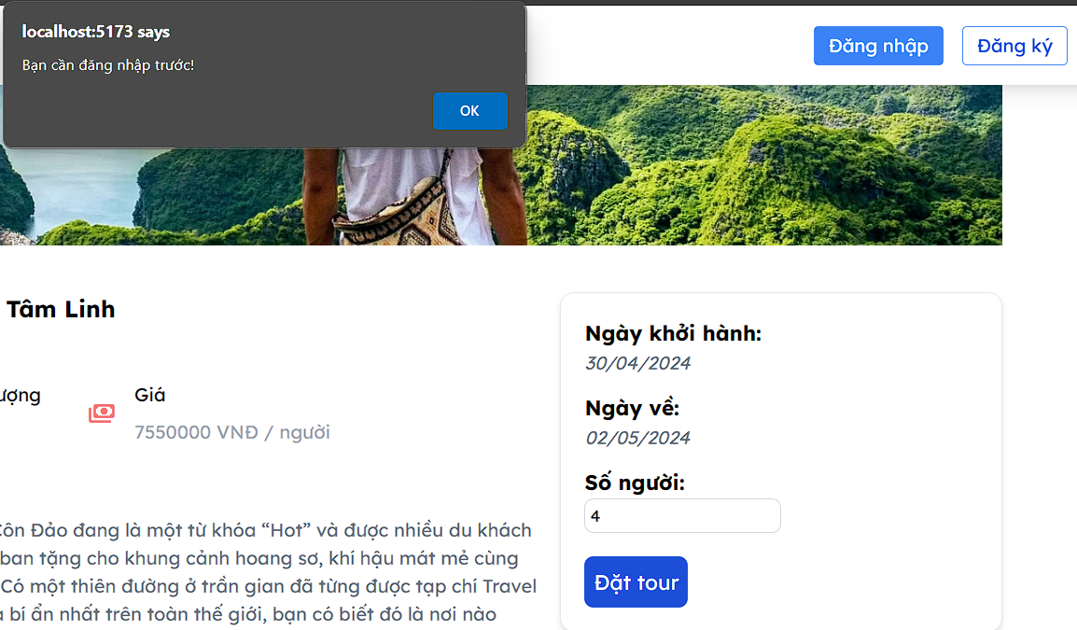

      - Filter interface
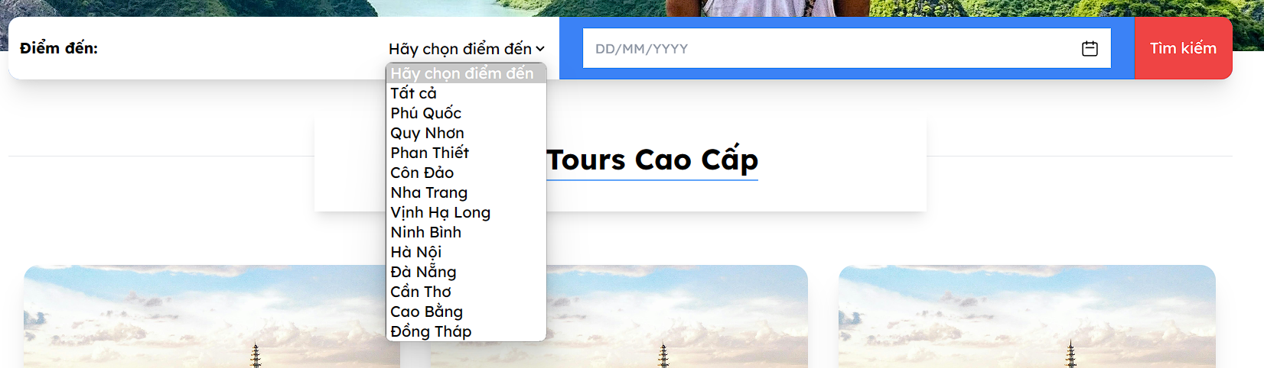
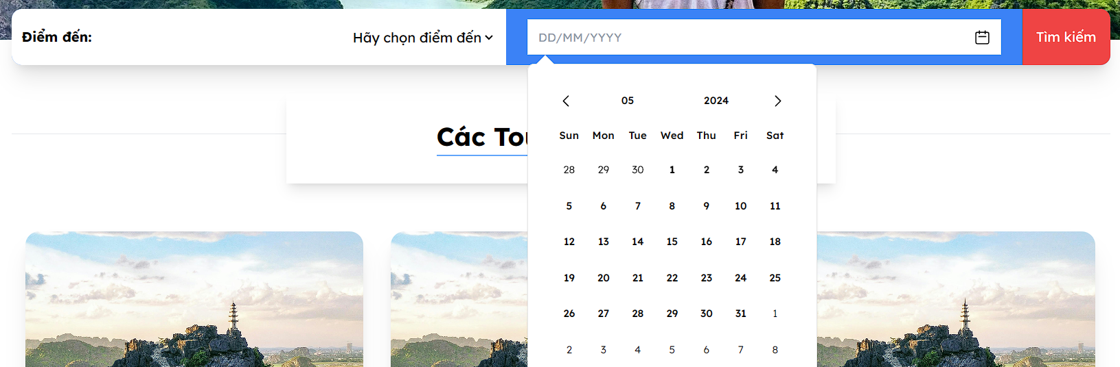

      - Tour Management interface

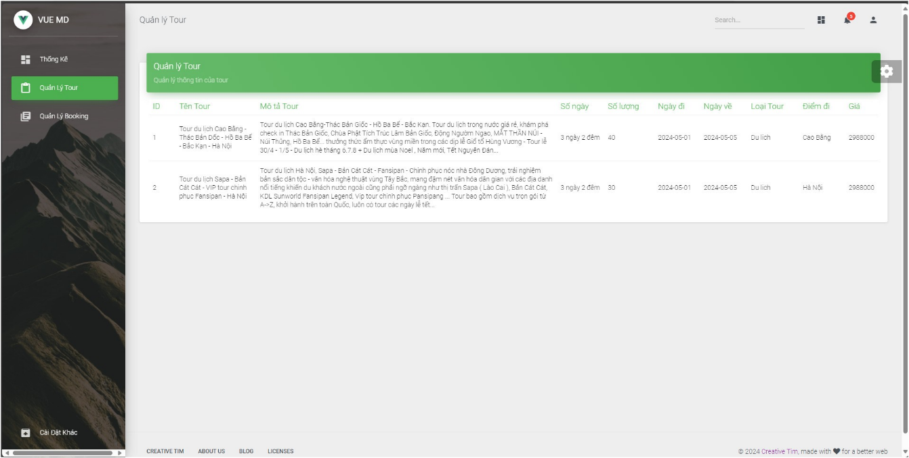
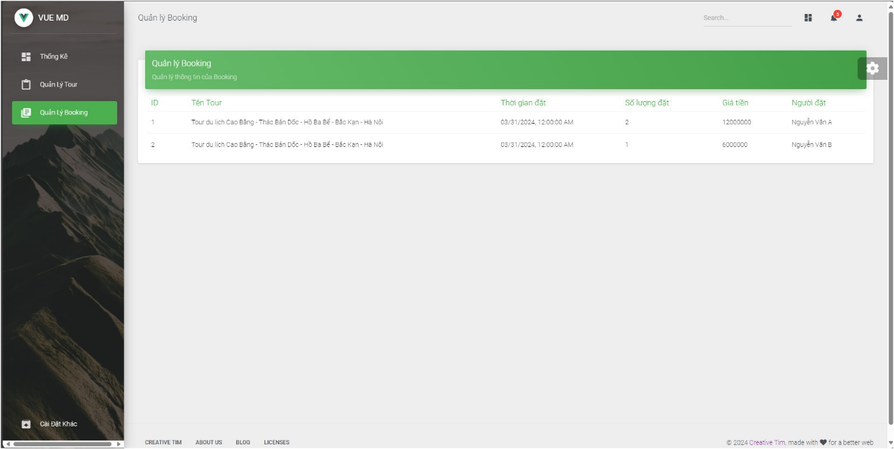
      - Booking Management

CHAPTER 3: CONCLUSION
- Result achieved
Through the process of research and development of the Vietnam Tourism Web project, the achieved result is a basic tour booking website with a user-friendly, intuitive, and easy-to-use interface. The website has applied modern technologies such as Vue.js, SpringBoot, and MySQL to create a website that operates reasonably well.
The website meets most of the initially outlined requirements as a simple tourism website, making it easily accessible to customers and also contributing to highlighting the beauty and culture of Vietnam.
- Limitation
Due to limited expertise and time, the website is still incomplete and has not met expectations. There are few features, and it is not sufficient to meet all the needs of tourists. The website is not optimized for other devices such as phones, tablets, and does not support multiple languages.
- Future Directions
To better meet the needs of customers, the website will add additional features and provide more international tours. We’ll also enhance the user experience by incorporating a guide system for quick and convenient customer interactions. Additionally, a chatbot system will assist tourists in addressing simple queries, and a messaging interface will facilitate communication with travel advisors and tour guides.

REFERENCES
[1] Vue.js: https://vuejs.org/
[2] Spring Boot: https://spring.io/
[3] MySQL: https://www.mysql.com/
[4] https://www.vietnam.vn/du-lich-viet-ky-vong-but-toc-trong-nam-2024/

